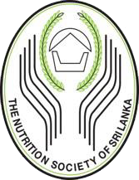

VOLUME 1
ISSUE 1
JANUARY 2022

THE OFFICIAL JOURNAL OF
THE NUTRITION SOCIETY OF SRI LANKA

ISSN 1234567890

